【院內已訂購之電子資源】

※ 路徑：醫學圖書館網頁 > 搜尋該電子資源名稱

**請務必於圖書室網頁右上角登入後使用**

一、**Lexicomp 藥學資料庫**

[Coronavirus Disease 2019 Vaccine Tracker](https://online.lexi.com/lco/action/doc/retrieve/docid/multinat_f/6991661?cesid=6buJoYGJChi&searchUrl=%2Flco%2Faction%2Fsearch%3Fq%3DCOVID-19%252520Vaccine%26t%3Dname%26va%3DCOVID-19%252520Vaccine) (彙整總表)

提供各廠牌Covid-19疫苗的試驗狀態及施打方式等總表。(Last Updated 3/15/21)

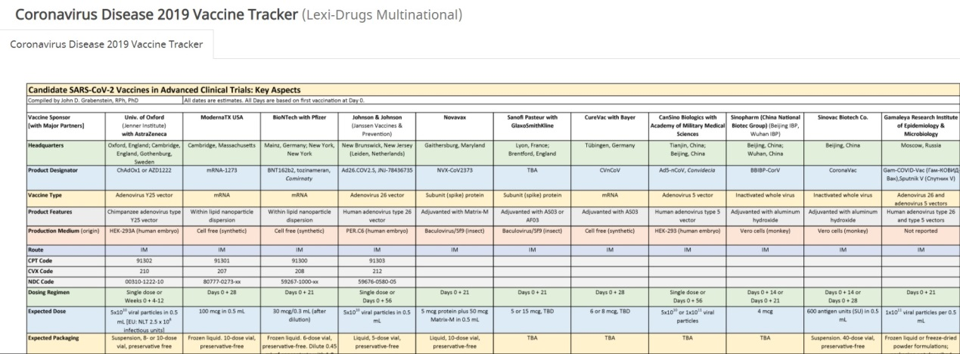

[Lexicomp Vaccine Tracker](https://go.wolterskluwer.com/rs/591-WJW-115/images/COVID-19%20Vaccine%20%28mRNA%29%20%28Lexi-Drugs%29%201-11.pdf)

提供疫苗最新動態及其臨床試驗結果。(Last Updated 1/8/21)

以下為疫苗相關的藥物資訊、感染控制、衛教資訊、過敏等資訊。

Lexi-Drugs Multinational

* [COVID-19 Vaccine (mRNA)](https://online.lexi.com/lco/action/doc/retrieve/docid/multinat_f/7043868?cesid=6buJoYGJChi&searchUrl=%2Flco%2Faction%2Fsearch%3Fq%3DCOVID-19%252520Vaccine%26t%3Dname%26va%3DCOVID-19%252520Vaccine) [Dosing](https://online.lexi.com/lco/action/doc/retrieve/docid/multinat_f/7043868?cesid=6buJoYGJChi&searchUrl=%2Flco%2Faction%2Fsearch%3Fq%3DCOVID-19%252520Vaccine%26t%3Dname%26va%3DCOVID-19%252520Vaccine#doa)| [Administration](https://online.lexi.com/lco/action/doc/retrieve/docid/multinat_f/7043868?cesid=6buJoYGJChi&searchUrl=%2Flco%2Faction%2Fsearch%3Fq%3DCOVID-19%252520Vaccine%26t%3Dname%26va%3DCOVID-19%252520Vaccine#aim)| [Adverse Reactions](https://online.lexi.com/lco/action/doc/retrieve/docid/multinat_f/7043868?cesid=6buJoYGJChi&searchUrl=%2Flco%2Faction%2Fsearch%3Fq%3DCOVID-19%252520Vaccine%26t%3Dname%26va%3DCOVID-19%252520Vaccine#arsc) *New 12/11/20*
* [COVID-19 Vaccine (Adenovirus Vector)](https://online.lexi.com/lco/action/doc/retrieve/docid/multinat_f/7052346?cesid=6buJoYGJChi&searchUrl=%2Flco%2Faction%2Fsearch%3Fq%3DCOVID-19%252520Vaccine%26t%3Dname%26va%3DCOVID-19%252520Vaccine) [Dosing](https://online.lexi.com/lco/action/doc/retrieve/docid/multinat_f/7052346?cesid=6buJoYGJChi&searchUrl=%2Flco%2Faction%2Fsearch%3Fq%3DCOVID-19%252520Vaccine%26t%3Dname%26va%3DCOVID-19%252520Vaccine#doa)| [Administration](https://online.lexi.com/lco/action/doc/retrieve/docid/multinat_f/7052346?cesid=6buJoYGJChi&searchUrl=%2Flco%2Faction%2Fsearch%3Fq%3DCOVID-19%252520Vaccine%26t%3Dname%26va%3DCOVID-19%252520Vaccine#aim)| [Adverse Reactions](https://online.lexi.com/lco/action/doc/retrieve/docid/multinat_f/7052346?cesid=6buJoYGJChi&searchUrl=%2Flco%2Faction%2Fsearch%3Fq%3DCOVID-19%252520Vaccine%26t%3Dname%26va%3DCOVID-19%252520Vaccine#adr) *New 1/6/21*
* [COVID-19 Vaccine (Inactivated Virus)](https://online.lexi.com/lco/action/doc/retrieve/docid/multinat_f/7070735?cesid=6buJoYGJChi&searchUrl=%2Flco%2Faction%2Fsearch%3Fq%3DCOVID-19%252520Vaccine%26t%3Dname%26va%3DCOVID-19%252520Vaccine) [Dosing](https://online.lexi.com/lco/action/doc/retrieve/docid/multinat_f/7070735?cesid=6buJoYGJChi&searchUrl=%2Flco%2Faction%2Fsearch%3Fq%3DCOVID-19%252520Vaccine%26t%3Dname%26va%3DCOVID-19%252520Vaccine#doa)| [Administration](https://online.lexi.com/lco/action/doc/retrieve/docid/multinat_f/7070735?cesid=6buJoYGJChi&searchUrl=%2Flco%2Faction%2Fsearch%3Fq%3DCOVID-19%252520Vaccine%26t%3Dname%26va%3DCOVID-19%252520Vaccine#aim)| [Adverse Reactions](https://online.lexi.com/lco/action/doc/retrieve/docid/multinat_f/7070735?cesid=6buJoYGJChi&searchUrl=%2Flco%2Faction%2Fsearch%3Fq%3DCOVID-19%252520Vaccine%26t%3Dname%26va%3DCOVID-19%252520Vaccine#adr) *New 2/22/21*
* [Coronavirus Disease 2019 Vaccine Tracker](https://online.lexi.com/lco/action/doc/retrieve/docid/multinat_f/6991661?cesid=6buJoYGJChi&searchUrl=%2Flco%2Faction%2Fsearch%3Fq%3DCOVID-19%252520Vaccine%26t%3Dname%26va%3DCOVID-19%252520Vaccine) *Updated 3/15/21*

Pediatric and Neonatal Lexi-Drugs

* [COVID-19 Vaccine (Adenovirus Vector)](https://online.lexi.com/lco/action/doc/retrieve/docid/pdh_f/7052697?cesid=6buJoYGJChi&searchUrl=%2Flco%2Faction%2Fsearch%3Fq%3DCOVID-19%252520Vaccine%26t%3Dname%26va%3DCOVID-19%252520Vaccine) [Dosing](https://online.lexi.com/lco/action/doc/retrieve/docid/pdh_f/7052697?cesid=6buJoYGJChi&searchUrl=%2Flco%2Faction%2Fsearch%3Fq%3DCOVID-19%252520Vaccine%26t%3Dname%26va%3DCOVID-19%252520Vaccine#dop)| [Administration](https://online.lexi.com/lco/action/doc/retrieve/docid/pdh_f/7052697?cesid=6buJoYGJChi&searchUrl=%2Flco%2Faction%2Fsearch%3Fq%3DCOVID-19%252520Vaccine%26t%3Dname%26va%3DCOVID-19%252520Vaccine#admp)| [Adverse Reactions](https://online.lexi.com/lco/action/doc/retrieve/docid/pdh_f/7052697?cesid=6buJoYGJChi&searchUrl=%2Flco%2Faction%2Fsearch%3Fq%3DCOVID-19%252520Vaccine%26t%3Dname%26va%3DCOVID-19%252520Vaccine#arsc) *New 1/11/21*
* [COVID-19 Vaccine (mRNA)](https://online.lexi.com/lco/action/doc/retrieve/docid/pdh_f/7043896?cesid=6buJoYGJChi&searchUrl=%2Flco%2Faction%2Fsearch%3Fq%3DCOVID-19%252520Vaccine%26t%3Dname%26va%3DCOVID-19%252520Vaccine) [Dosing](https://online.lexi.com/lco/action/doc/retrieve/docid/pdh_f/7043896?cesid=6buJoYGJChi&searchUrl=%2Flco%2Faction%2Fsearch%3Fq%3DCOVID-19%252520Vaccine%26t%3Dname%26va%3DCOVID-19%252520Vaccine#dop)| [Administration](https://online.lexi.com/lco/action/doc/retrieve/docid/pdh_f/7043896?cesid=6buJoYGJChi&searchUrl=%2Flco%2Faction%2Fsearch%3Fq%3DCOVID-19%252520Vaccine%26t%3Dname%26va%3DCOVID-19%252520Vaccine#admp)| [Adverse Reactions](https://online.lexi.com/lco/action/doc/retrieve/docid/pdh_f/7043896?cesid=6buJoYGJChi&searchUrl=%2Flco%2Faction%2Fsearch%3Fq%3DCOVID-19%252520Vaccine%26t%3Dname%26va%3DCOVID-19%252520Vaccine#arsc) *New 12/11/20*

AHFS Essentials (Adult and Pediatric)

* [COVID-19 Vaccine (Moderna)](https://online.lexi.com/lco/action/doc/retrieve/docid/essential_ashp/7070105?cesid=6buJoYGJChi&searchUrl=%2Flco%2Faction%2Fsearch%3Fq%3DCOVID-19%252520Vaccine%26t%3Dname%26va%3DCOVID-19%252520Vaccine) *New 2/26/21*
* [COVID-19 Vaccine (PFizer-BioNTech)](https://online.lexi.com/lco/action/doc/retrieve/docid/essential_ashp/7070104?cesid=6buJoYGJChi&searchUrl=%2Flco%2Faction%2Fsearch%3Fq%3DCOVID-19%252520Vaccine%26t%3Dname%26va%3DCOVID-19%252520Vaccine) *New 2/26/21*

AHFS DI (Adult and Pediatric)

* [COVID-19 Vaccine (Moderna)](https://online.lexi.com/lco/action/doc/retrieve/docid/complete_ashp/7070096?cesid=6buJoYGJChi&searchUrl=%2Flco%2Faction%2Fsearch%3Fq%3DCOVID-19%252520Vaccine%26t%3Dname%26va%3DCOVID-19%252520Vaccine) *New 2/26/21*
* [COVID-19 Vaccine (PFizer-BioNTech)](https://online.lexi.com/lco/action/doc/retrieve/docid/complete_ashp/7070095?cesid=6buJoYGJChi&searchUrl=%2Flco%2Faction%2Fsearch%3Fq%3DCOVID-19%252520Vaccine%26t%3Dname%26va%3DCOVID-19%252520Vaccine) *New 2/26/21*

Infectious Diseases

* [COVID-19 Vaccine (Adenovirus Vector)](https://online.lexi.com/lco/action/doc/retrieve/docid/idh/7076789?cesid=6buJoYGJChi&searchUrl=%2Flco%2Faction%2Fsearch%3Fq%3DCOVID-19%252520Vaccine%26t%3Dname%26va%3DCOVID-19%252520Vaccine) *New 3/2/21*
* [COVID-19 Vaccine (mRNA)](https://online.lexi.com/lco/action/doc/retrieve/docid/idh/7043909?cesid=6buJoYGJChi&searchUrl=%2Flco%2Faction%2Fsearch%3Fq%3DCOVID-19%252520Vaccine%26t%3Dname%26va%3DCOVID-19%252520Vaccine) *New 12/11/20*
* [COVID-19 Vaccine (Subunit)](https://online.lexi.com/lco/action/doc/retrieve/docid/idh/7076790?cesid=6buJoYGJChi&searchUrl=%2Flco%2Faction%2Fsearch%3Fq%3DCOVID-19%252520Vaccine%26t%3Dname%26va%3DCOVID-19%252520Vaccine) *New 3/2/21*

Patient Education - Disease and Procedure

* [COVID-19 Vaccines](https://online.lexi.com/lco/action/doc/retrieve/docid/disandproc/7047146?cesid=6buJoYGJChi&searchUrl=%2Flco%2Faction%2Fsearch%3Fq%3DCOVID-19%252520Vaccine%26t%3Dname%26va%3DCOVID-19%252520Vaccine) *New 12/18/20*
* [COVID-19 Vaccine (mRNA) Pfizer FDA Fact Sheet](https://online.lexi.com/lco/action/doc/retrieve/docid/disandproc/7044371?cesid=6buJoYGJChi&searchUrl=%2Flco%2Faction%2Fsearch%3Fq%3DCOVID-19%252520Vaccine%26t%3Dname%26va%3DCOVID-19%252520Vaccine) *New 12/14/20*
* [COVID-19 Vaccine (mRNA) Moderna FDA Fact Sheet](https://online.lexi.com/lco/action/doc/retrieve/docid/disandproc/7052271?cesid=6buJoYGJChi&searchUrl=%2Flco%2Faction%2Fsearch%3Fq%3DCOVID-19%252520Vaccine%26t%3Dname%26va%3DCOVID-19%252520Vaccine) *New 1/6/21*
* [COVID-19 Vaccine (Adenovirus Vector) Janssen FDA Fact Sheet](https://online.lexi.com/lco/action/doc/retrieve/docid/disandproc/7075230?cesid=6buJoYGJChi&searchUrl=%2Flco%2Faction%2Fsearch%3Fq%3DCOVID-19%252520Vaccine%26t%3Dname%26va%3DCOVID-19%252520Vaccine) *New 3/1/21*
* [Coronavirus Disease 2019 (COVID-19) After You Have Been Vaccinated](https://online.lexi.com/lco/action/doc/retrieve/docid/disandproc/7066920?cesid=6buJoYGJChi&searchUrl=%2Flco%2Faction%2Fsearch%3Fq%3DCOVID-19%252520Vaccine%26t%3Dname%26va%3DCOVID-19%252520Vaccine) *New 2/4/21*

Patient Education Multinational - Adult Medication

* [COVID-19 Vaccine (mRNA)](https://online.lexi.com/lco/action/doc/retrieve/docid/patedmulti_f/7046621?cesid=6buJoYGJChi&searchUrl=%2Flco%2Faction%2Fsearch%3Fq%3DCOVID-19%252520Vaccine%26t%3Dname%26va%3DCOVID-19%252520Vaccine) *New 12/15/20*
* [COVID-19 Vaccine (Inactivated Virus)](https://online.lexi.com/lco/action/doc/retrieve/docid/patedmulti_f/7064923?cesid=6buJoYGJChi&searchUrl=%2Flco%2Faction%2Fsearch%3Fq%3DCOVID-19%252520Vaccine%26t%3Dname%26va%3DCOVID-19%252520Vaccine) *New 1/28/21*

Facts and Comparisons A to Z Drugs

* [COVID-19 Vaccine (mRNA)](https://online.lexi.com/lco/action/doc/retrieve/docid/fc_atoz2/7043907?cesid=6buJoYGJChi&searchUrl=%2Flco%2Faction%2Fsearch%3Fq%3DCOVID-19%252520Vaccine%26t%3Dname%26va%3DCOVID-19%252520Vaccine) *New 12/11/20*
* [COVID-19 Vaccine (Adenovirus Vector)](https://online.lexi.com/lco/action/doc/retrieve/docid/fc_atoz2/7075232?cesid=6buJoYGJChi&searchUrl=%2Flco%2Faction%2Fsearch%3Fq%3DCOVID-19%252520Vaccine%26t%3Dname%26va%3DCOVID-19%252520Vaccine) *New 3/1/21*

Drug Allergy and Idiosyncratic Reactions

* [COVID-19 Vaccine (mRNA)](https://online.lexi.com/lco/action/doc/retrieve/docid/allergy_f/7047034?cesid=6buJoYGJChi&searchUrl=%2Flco%2Faction%2Fsearch%3Fq%3DCOVID-19%252520Vaccine%26t%3Dname%26va%3DCOVID-19%252520Vaccine) *New 12/17/20*

二、**UpTodate**

在UpToDate 中, 除了有COVID-19專區, 專區下面也有專門針對疫苗的主題

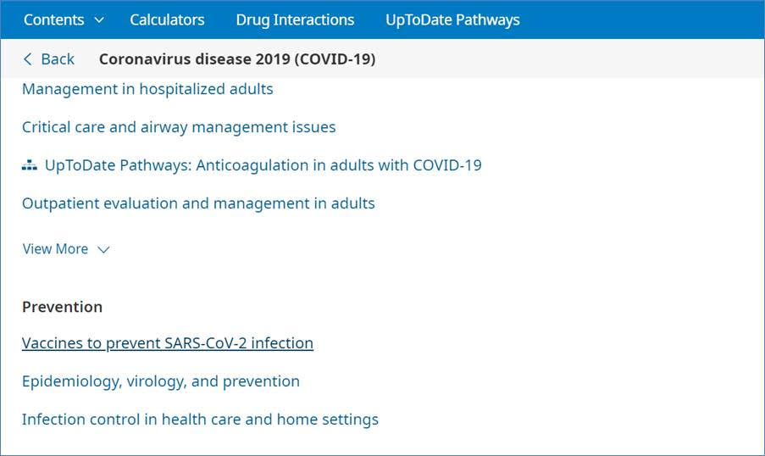

文章 **COVID-19: Vaccines to prevent SARS-CoV-2 infection**

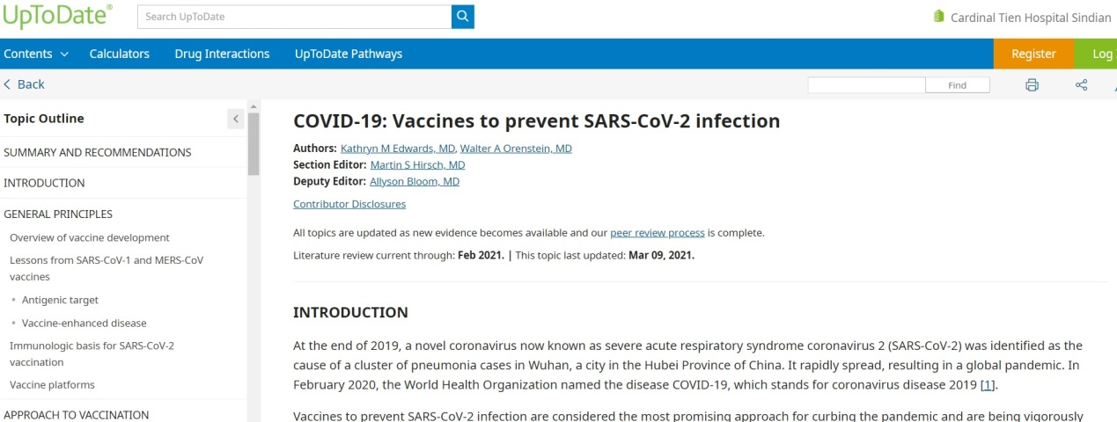

**三、NEJM**

COVID-19專區最新文獻

Delayed Large Local Reactions to mRNA-1273 Vaccine against SARS-CoV-2

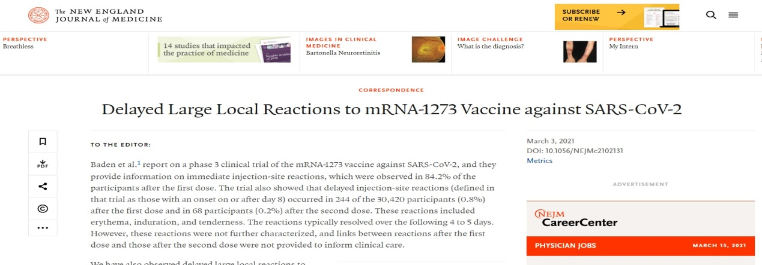

**Safety and Efficacy of the BNT162b2 mRNA Covid-19 Vaccine**

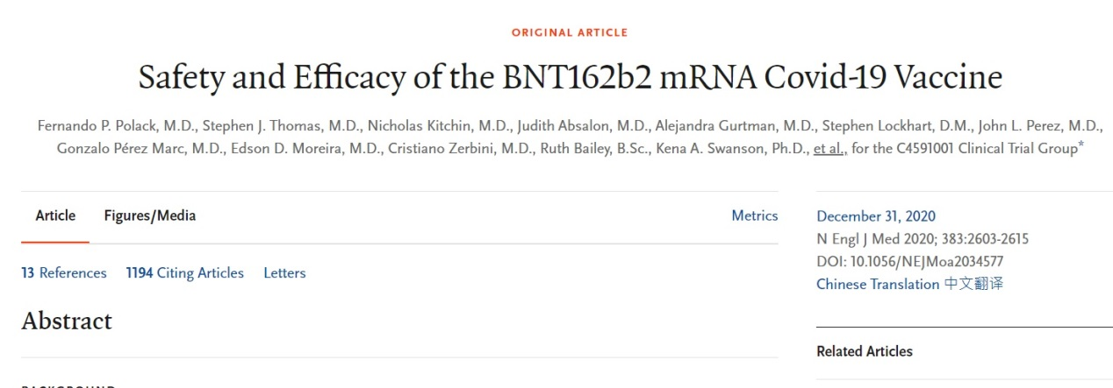

**0803 Nature 引用的原文(詳細介紹見蘇一峰醫師文章)**

蘇醫師文章連結 <https://tvgh-suvy.blogspot.com/2021/07/naturecovid-19nejm.html?m=1>

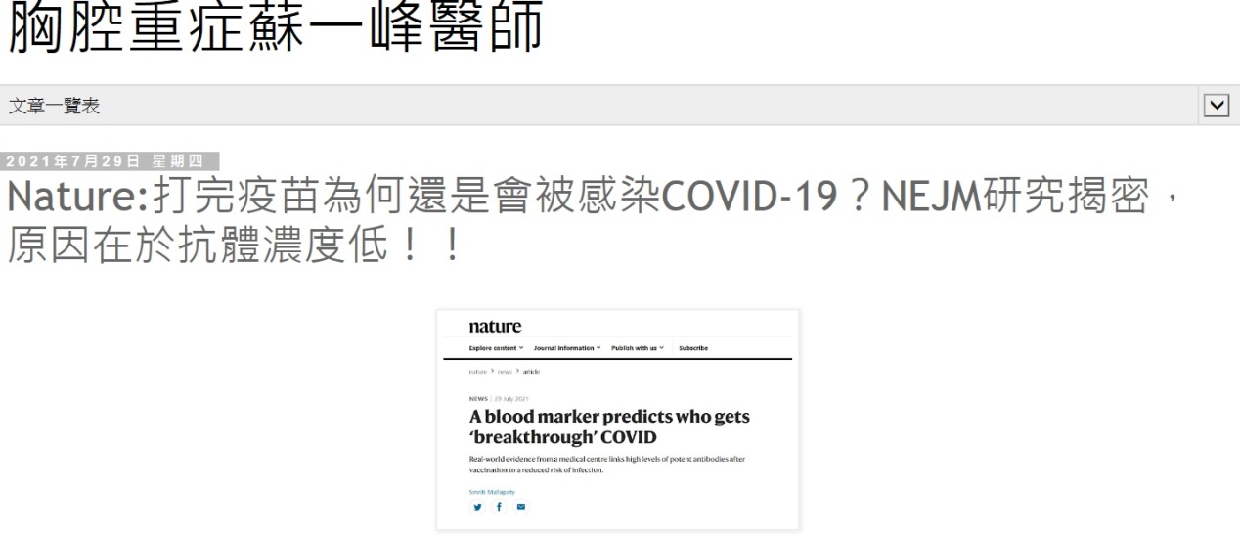

原文連結

<https://www.nejm.org/doi/full/10.1056/NEJMoa2101765?query=featured_coronavirus>

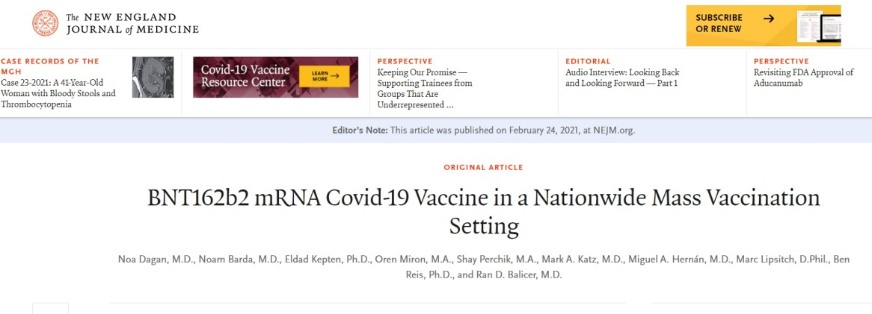

**四、ClinicalKey 藥物指引**

搜尋Covid-19 進入相關資源集中區



選取左下方獲得藥物指引

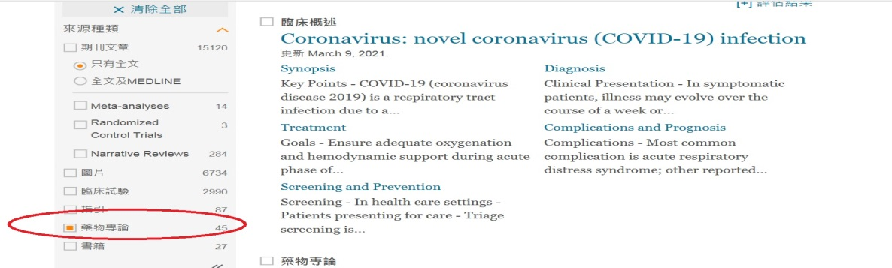

也可以直接搜尋

covid-19 vaccine

1020 高端新冠肺炎疫苗二期數據 於Lancet RM期刊審查發表

全文於 ClinicalKey 可下載

Safety and immunogenicity of CpG 1018 and aluminium hydroxide-adjuvanted SARS-CoV-2 S-2P protein vaccine MVC-COV1901: interim results of a large-scale, double-blind, randomised, placebo-controlled phase 2 trial in Taiwan

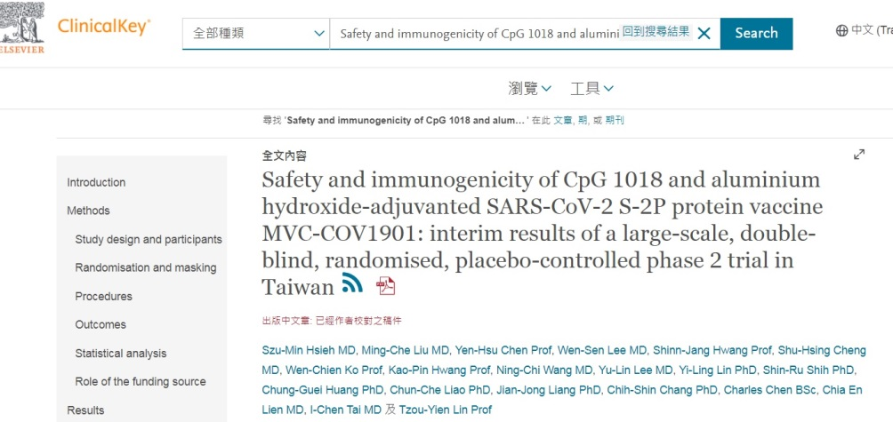

**五、熱病資料庫**

混打疫苗資訊整理請見附件PDF檔

使用諮詢請參考圖書館指引

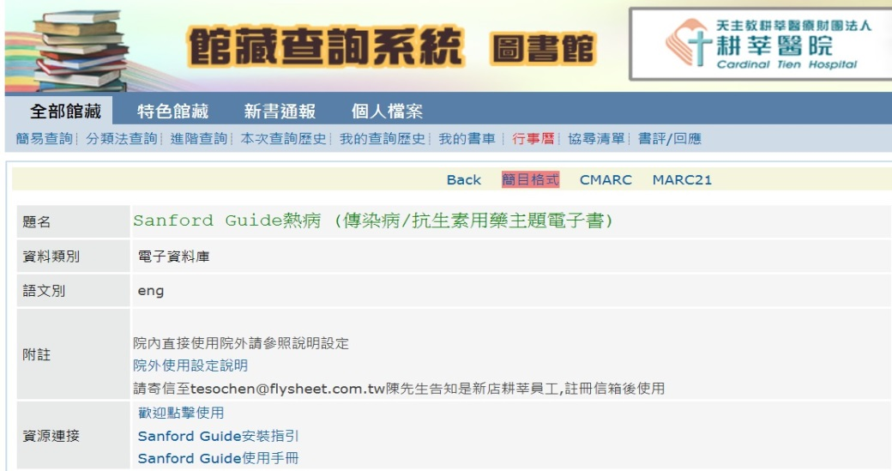

【免費資源】

**一、FDA(美國食藥署)關於各疫苗的相關資訊**

<https://www.fda.gov/emergency-preparedness-and-response/coronavirus-disease-2019-covid-19/covid-19-vaccines>

## 二、EBSCO新冠病毒疫苗的決策輔助資源工具

簡介 <https://www.ebsco.com/e/zh-tw/blog/creation-covid-19-vaccine-decision-aid>

下載(PDF)

<https://www.ebsco.com/sites/g/files/nabnos191/files/acquiadam-assets/DynaMed-Shared-Decisions-COVID-19-Vaccine-Decision-Aid.pdf>

**三、約翰·霍普金斯大學線上指南**

COVID-19會話-變體，疫苗和長期效果

<https://www.hopkinsguides.com/hopkins/view/Message_Center_-_Hopkins_Guides/2015014/all/A_COVID_19_Conversation___Variants__Vaccines__and_Long_Term_Effects?svar=a%7cub&svar=c%7cJHU_Web_FU_ENA_May21&akey=00086983537&utm_source=img&utm_medium=em&utm_campaign=JHU_Web_FU_ENA_May21>

(youtube影片請用非醫院電腦開啟)